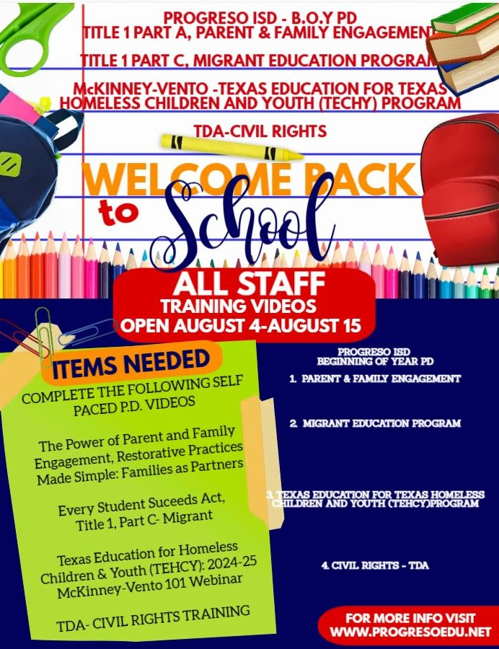

**ENGLISH**

<https://ilearn.theicn.org/learn/courses/122/civil-rights-in-child-nutrition-programs>

**SPANISH**

<https://ilearn.theicn.org/learn/courses/199/civil-rights-spanish-derechos-civiles-en-los-programas-de-nutricion-infantil>

<https://www.youtube.com/watch?v=YTaKb5ZWknQ>

<https://tetnvideo.hosted.panopto.com/Panopto/Pages/Viewer.aspx?id=30ace4de-07b7-4a32-b200-af230124f1df>

<https://tetnvideo.hosted.panopto.com/Panopto/Pages/Viewer.aspx?id=13aa1c78-88c1-4196-970a-af23012518dd>

<https://www.youtube.com/watch?v=yb6efqL_fv4&t=227s>

<https://tetnvideo.hosted.panopto.com/Panopto/Pages/Viewer.aspx?id=30ace4de-07b7-4a32-b200-af230124f1df>

<https://www.youtube.com/watch?v=yb6efqL_fv4&t=227s>